**Addressing Table**

|  |  |  |  |  |
| --- | --- | --- | --- | --- |
| **Device** | **Interface** | **IP Address / Prefix** | | **Default Gateway** |
| R1 | G0/0 | 10.10.1.97 | 255.255.255.224 | N/A |
| *R1* | *G0/0* | 2001:db8:1:1::1/64 | | *N/A* |
| *R1* | S0/0/1 | 10.10.1.6 | 255.255.255.252 | N/A |
| *R1* | *S0/0/1* | 2001:db8:1:2::2/64 | | *N/A* |
| *R1* | *S0/0/1* | fe80::1 | | *N/A* |
| R2 | S0/0/0 | 10.10.1.5 | 255.255.255.252 | N/A |
| *R2* | *S0/0/0* | 2001:db8:1:2::1/64 | | *N/A* |
| *R2* | S0/0/1 | 10.10.1.9 | 255.255.255.252 | N/A |
| *R2* | *S0/0/1* | 2001:db8:1:3::1/64 | | *N/A* |
| *R2* | *S0/0/1* | fe80::2 | | *N/A* |
| R3 | G0/0 | 10.10.1.17 | 255.255.255.240 | N/A |
| *R3* | *G0/0* | 2001:db8:1:4::1/64 | | *N/A* |
| *R3* | S0/0/1 | 10.10.1.10 | 255.255.255.252 | N/A |
| *R3* | *S0/0/1* | 2001:db8:1:3::2/64 | | *N/A* |
| *R3* | *S0/0/1* | fe80::3 | | *N/A* |
| PC1 | NIC | 10.10.1.100 | 255.255.255.224 | 10.10.1.97 |
| *PC1* | *NIC* | 2001:DB8:1:1::A | | FE80::1 |
| PC2 | NIC | 10.10.1.20 | 255.255.255.240 | 10.10.1.17 |
| *PC2* | *NIC* | 2001:DB8:1:4::A | | FE80::3 |

**Part 1**

* **PC1**

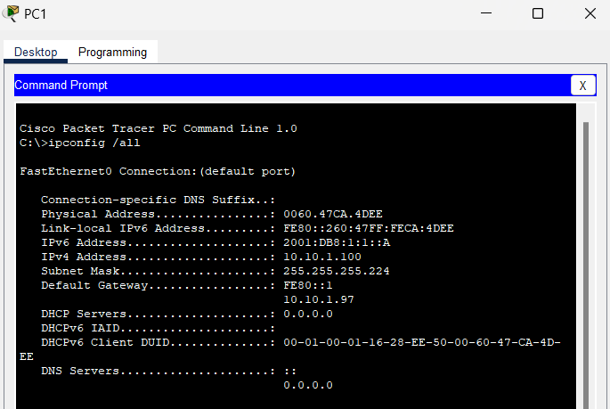

* **PC2**

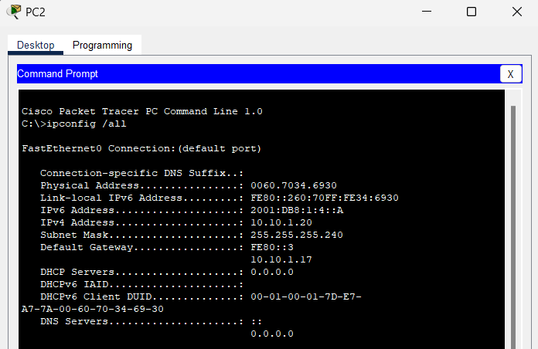

**Part 2**

* **Step 1:**

a.     From PC1, ping the IPv4 address for PC2.

Was the result successful? **Yes**

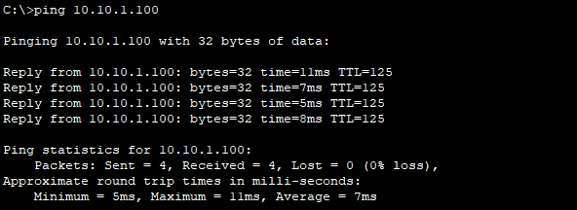

b.     From PC2, ping the IPv4 address for PC1.

Was the result successful? **Yes**

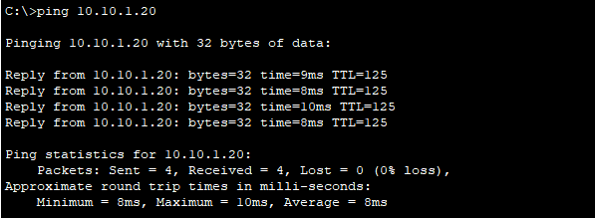

* **Step 2:**

a.     From PC1, ping the IPv6 address for PC2.

Was the result successful? **Yes**

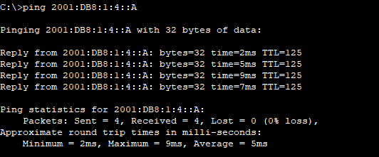

From PC2, ping the IPv6 address of PC1.

Was the result successful? **Yes**

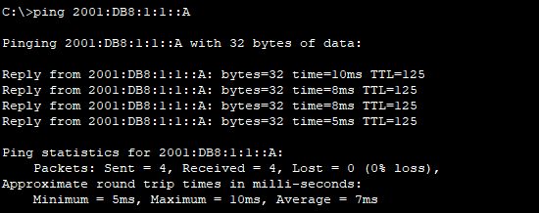

**Part 3**

* **Step 1**

a.From PC1, trace the route to PC2.

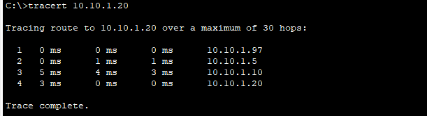

What addresses were encountered along the path? **10.10..1.97, 10.10.1.5, 10.10.1.10, 10.10.1.20**

With which interfaces are the four addresses associated? **G0/0 of R1, S0/0/0 on R2, S0/0/01 on R3, NIC of PC2**

b.     From PC2, trace the route to PC1.

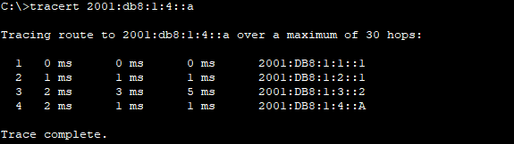

What addresses were encountered along the path? **10.10.1.17, 10.10.1.9, 10.10.1.6, 10.10.1.100**

With which interfaces are the four addresses associated? **G0/0 of R3, S0/0/1 of R2, S0/0/1 of R1, NIC of PC1**

* **Step 2**

a.     From PC1, trace the route to the IPv6 address for PC2.

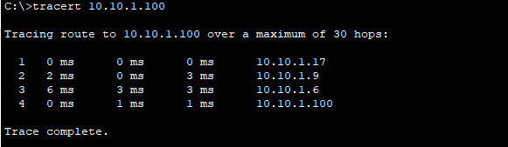

What addresses were encountered along the path? **2001:db8:1:1::1, 2001:db8:1:2::1, 2001:db8:1:3::2, 2001:db8:1:4::a**

With which interfaces are the four addresses associated? **G0/0 of R1, S0/0/0 of r2, S0/0/1 of R3, NIC of PC2**

b.     From PC2, trace the route to the IPv6 address for PC1.

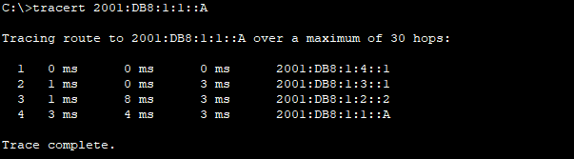

What addresses were encountered along the path? **2001:db8:1:4::1, 2001:db8:1:3::1, 2001:db8:1:2::2, 2001:db8:1:1::a**

With which interfaces are the four addresses associated? **G0/0 of R3, S0/0/1 of R2, S0/0/1 of R1, NIC of PC1**